Assessment Scheme – Interdisciplinary Education Design
Interdisciplinary Learning Objective  By the end of this unit, students are able to… | Assessment and Grading Source | Weighting Factor | Conditions
- (E.g.) …describe the multiple disciplinary perspectives applicable within the group challenge. | Assignment 1 – Group Report (rubric*) | 10% | $≥$ 5.5
 | Assignment 1- Group Report (rubric*) | 13% | $≥$ 5.5
 | Assignment 1 – Group Report (rubric*),  Assignment 2 - Prototype (rubric*) | 15% | $≥$ 5.5
 |  | 25% | $≥$ 6
 | Assignment 2 - Prototype (rubric*) | 20% | $≥$ 6
 | Assignment 3 – Individual Reflection (rubric) | 10% | Complete/Incomplete  (written feedback)
 | Presentation – Success Criteria | 7% | Complete/Incomplete (verbal feedback)
*Rubric with accompanying scoring.
Generic example:
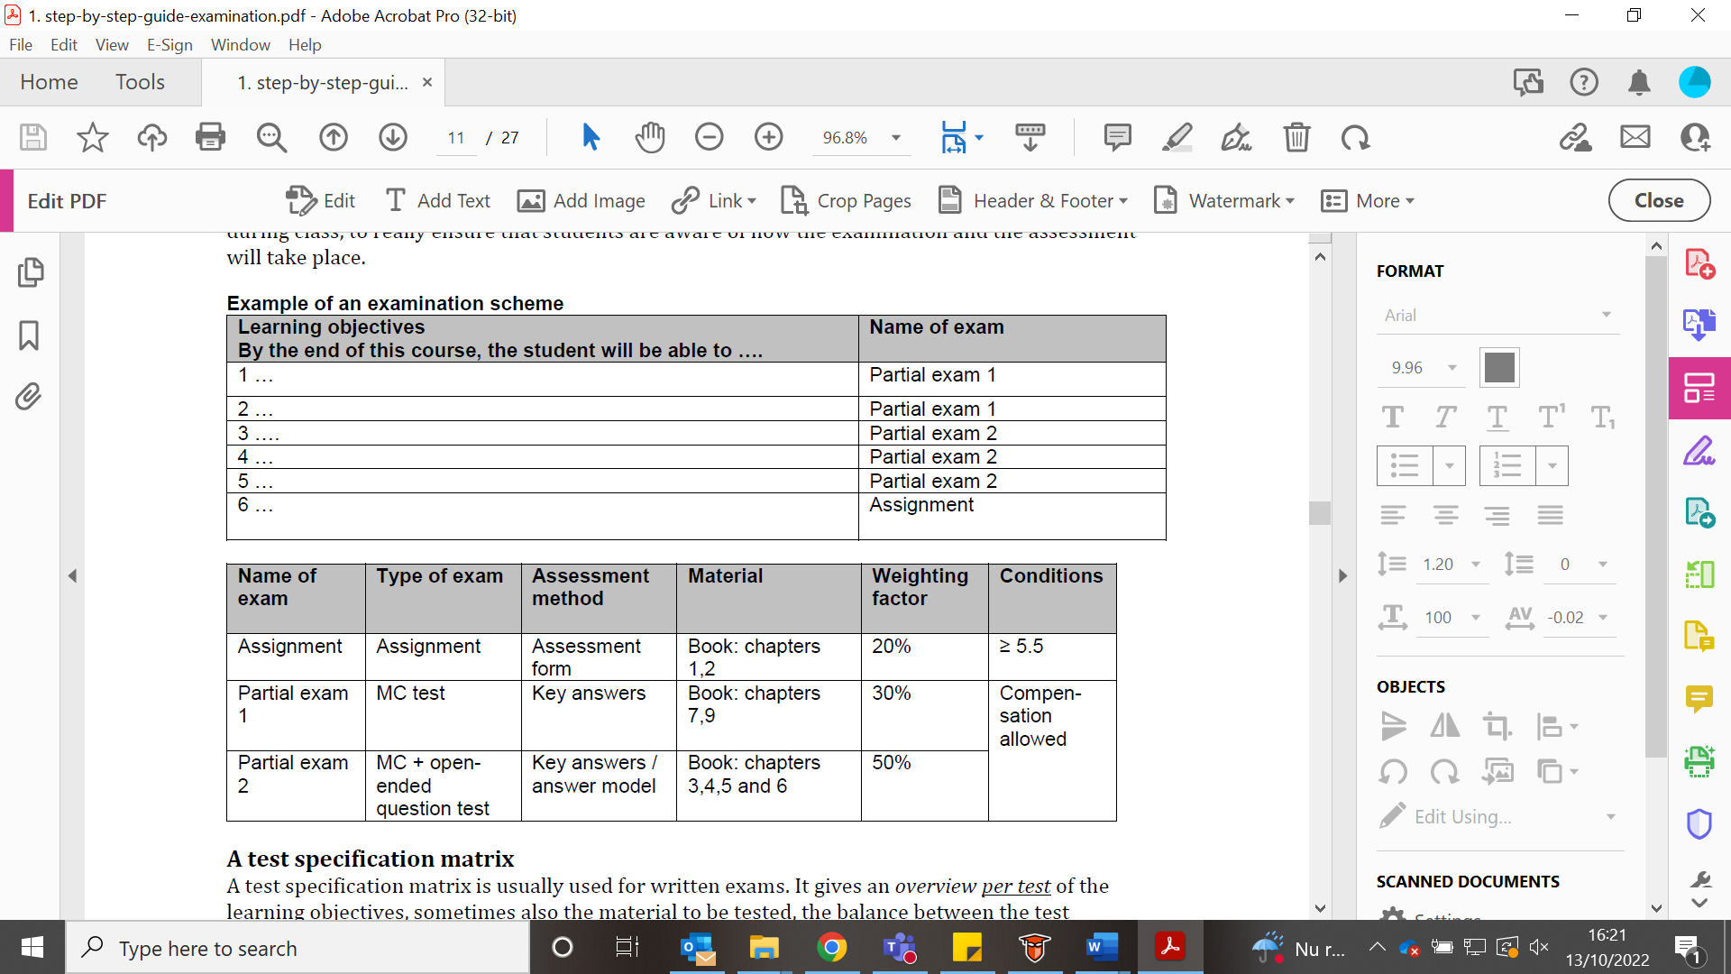
Taken from Utwente CELT website (Step by step guide examination)

